**DAILY ONLINE ACTIVITIES SUMMARY**

|  |  |  |  |  |  |  |  |
| --- | --- | --- | --- | --- | --- | --- | --- |
| **Date:** | **07/06/20** | | | | **Name:** | **Varsha H Shetty** | |
| **Sem & Sec** | **8th sem, B sec** | | | | **USN:** | **4AL16CS117** | |
| **Online Test Summary** | | | | | | | |
| **Subject** | | **Not conducted** | | | | | |
| **Max. Marks** | |  | | **Score** | |  | |
| **Certification Course Summary** | | | | | | | |
| **Course** | **AWS security fundamentals** | | | | | | |
| **Certificate Provider** | | | **AWS learning** | **Duration** | | | **2 hours** |
| **Coding Challenges** | | | | | | | |
| **Problem Statement: program to multiply two floating point numbers** | | | | | | | |
| **Status: Completed** | | | | | | | |
| **Uploaded the report in Github** | | | | **Yes** | | | |
| **If yes Repository name** | | | | **Varsha-Shetty** | | | |
| **Uploaded the report in slack** | | | | **Yes** | | | |

Online Test Details:

Not conducted

Certification Course Details:

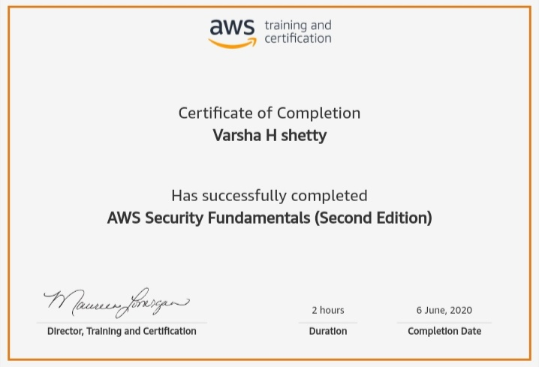

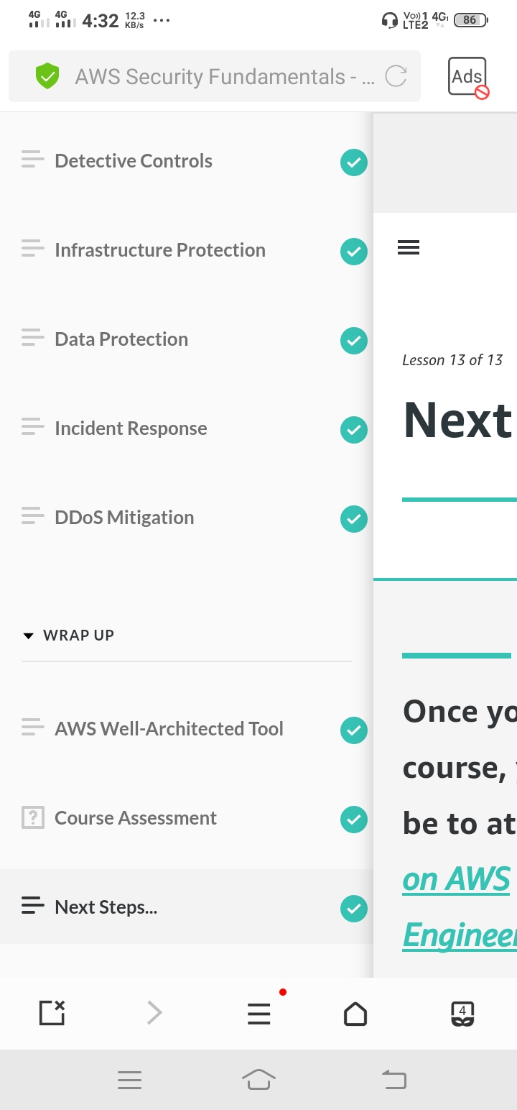

Coding Challenges Details:

#include <stdio.h>

int main() {

double a, b, product;

printf("Enter two numbers: ");

scanf("%lf %lf", &a, &b);

product = a * b;

// Result up to 2 decimal point is displayed using %.2lf

printf("Product = %.2lf", product);

return 0;

}